P Sai Koushik
2200032991
JUNIT SAMPLE TESTING
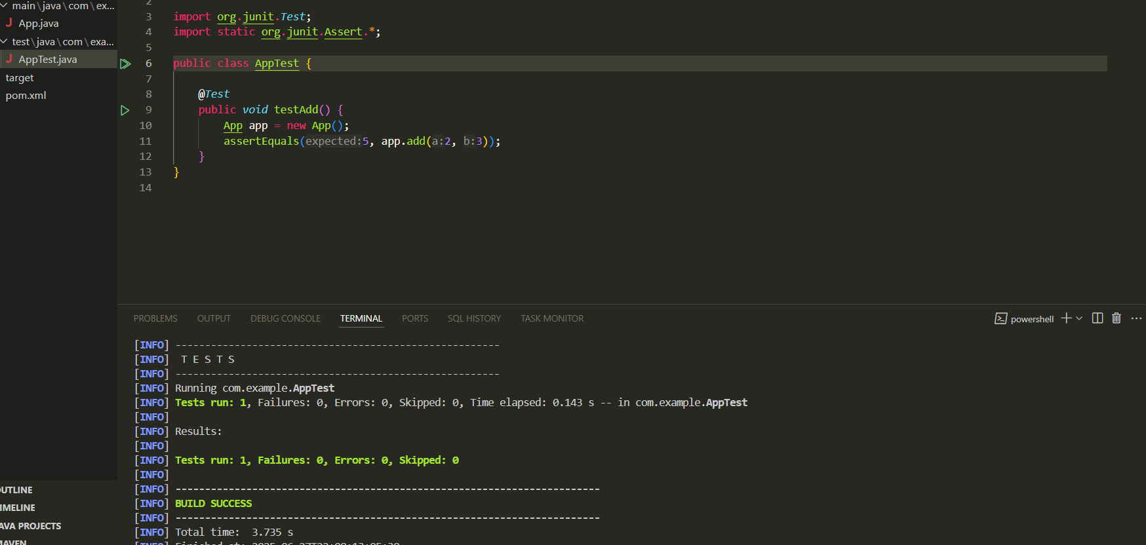
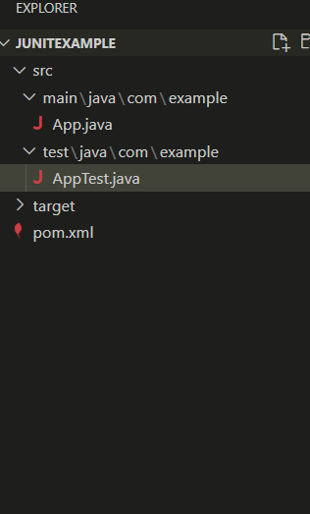

Apptest.java
package com.example;

import org.junit.Test;
import static org.junit.Assert.*;

public class AppTest {

@Test
public void testAdd() {
App app = new App();
assertEquals(5, app.add(2, 3));
}
}

App.java
package com.example;

public class App {
public int add(int a, int b) {
return a + b;
}

public static void main(String[] args) {
App app = new App();
System.out.println("Sum: " + app.add(2, 3));
}
}

